**DATA CLEANING AND TRANSFORMATION , RANKING AND STORED PROCEDURE**

Data cleaning involves the identification and removal of inaccuracies, inconsistencies, or irrelevant information from a dataset. It aims to eliminate data that is erroneous, incomplete, or does not belong in the dataset.

On the other hand, data transformation refers to the conversion of data from its original format or structure into a different, more usable form. This process may involve reformatting, aggregating, or modifying the data to make it suitable for analysis or integration with other datasets.

1. CREATED DATABASE “DEMO” AND CREATE A TABLE

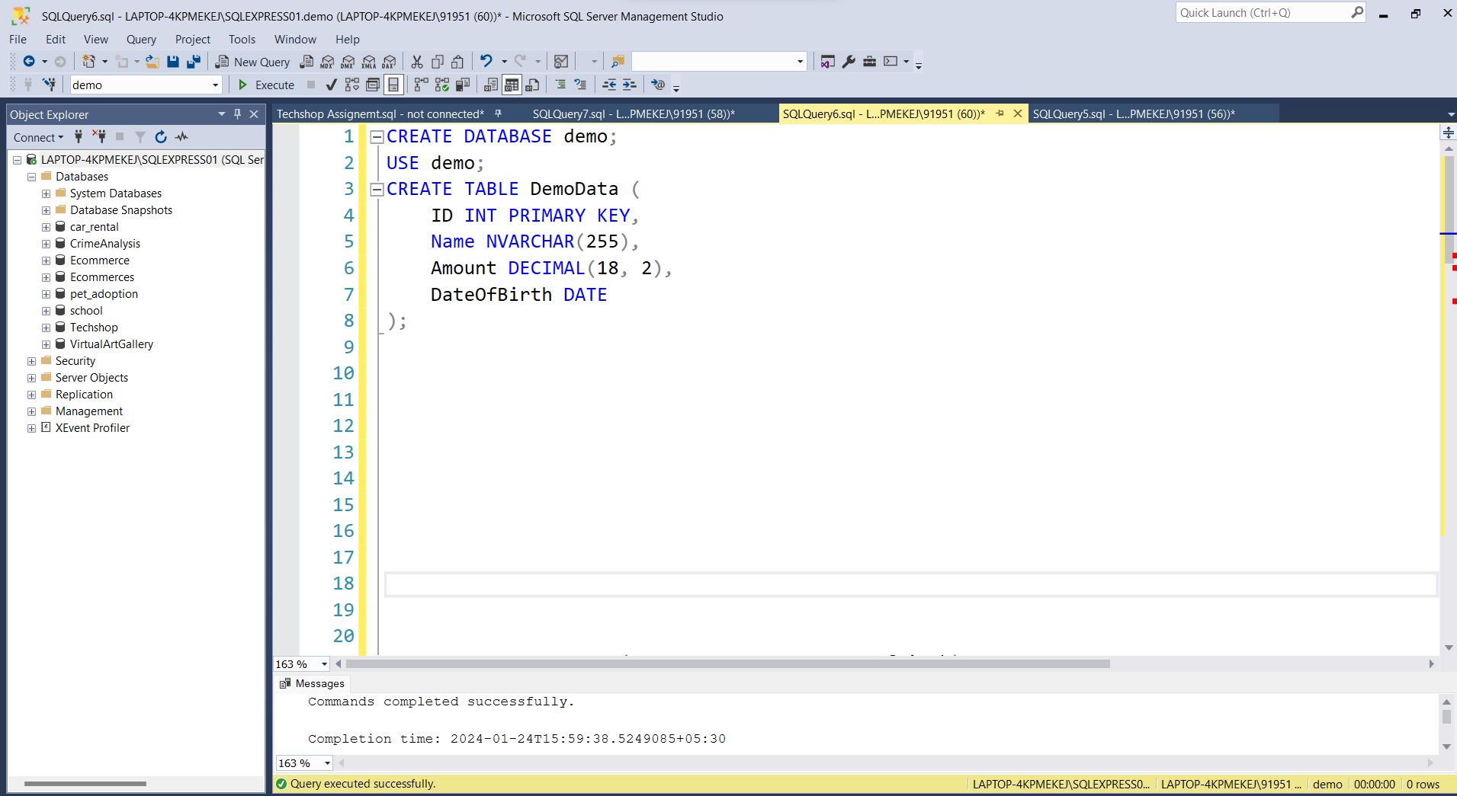

1. INSERTED VALUES TO THE TABLE

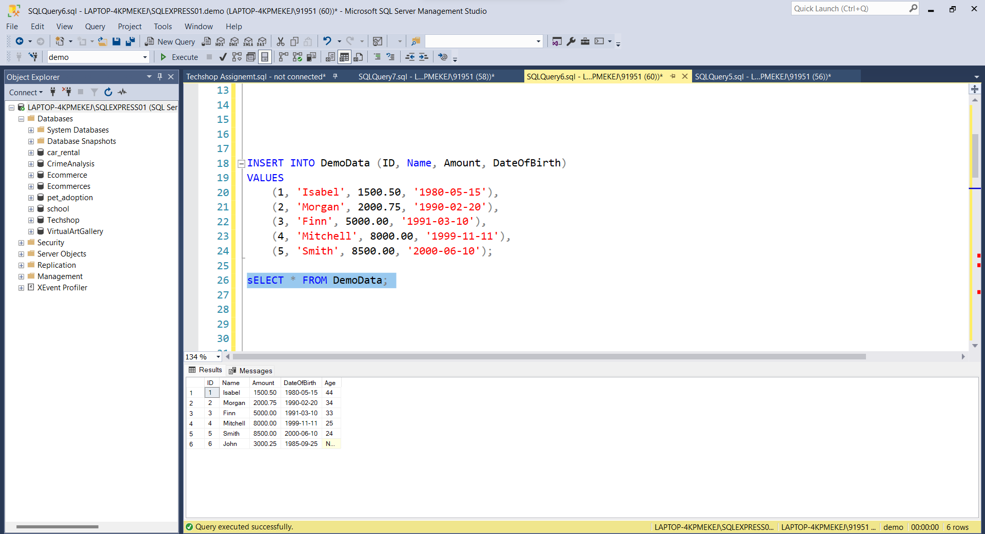

1. NOW WE HAVE DELETED ROWS WITH NULL VALUES

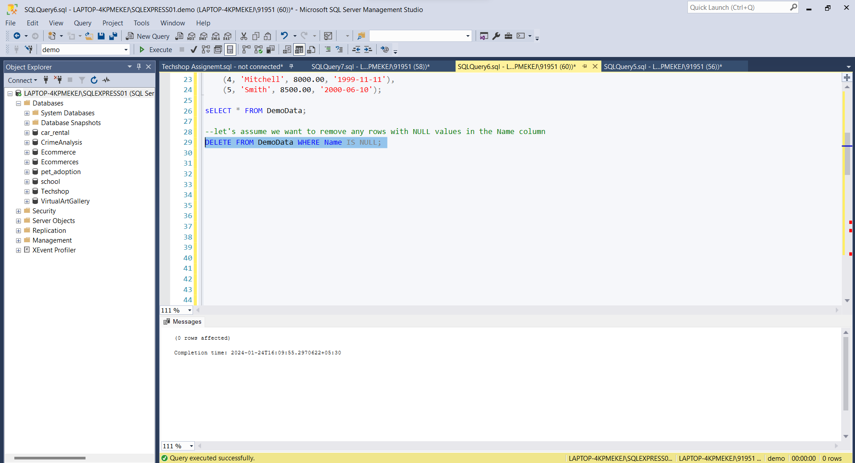

1. RANKING THE DATA AND DISPLAYING IT

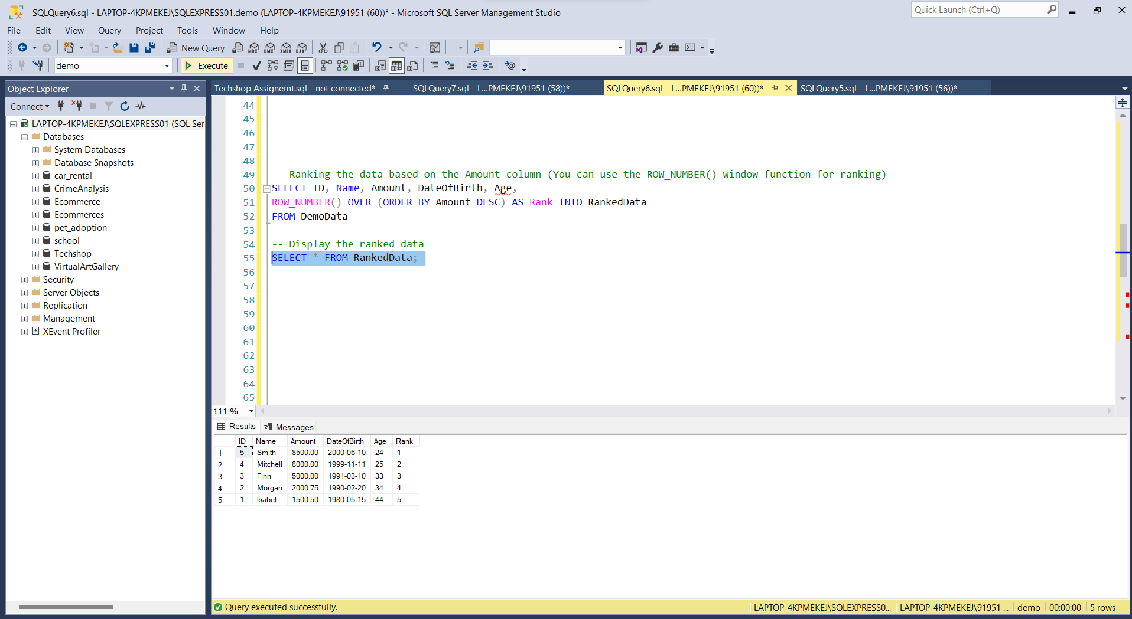

1. CREATING PROCEDURE, INSERTING AND RETRIEVING THE DATA FROM PROCEDURE

